Student Name: Phạm Thành Đạt

Student ID: 20521175

Contents

LINK GITHUB: Lab1-MSIS207.O12.CTTT 2

CLASSWORK 2

Exercise 1. 2

1. First implementation 2

2. First implementation – Table 6

3. First implementation – Form 8

Exercise 2. 9

Exercise 3. Using your knowledge of html and CSS, add the GENERAL NOTICE section of daa.uit.edu.vn to index-2.html 10

- index-2.html code 10

- app.css code 12

- Result 18

HOMEWORK 19

Homework 1. Upgrade your exercise 2 – The CV. Using CSS and making as this sample. 19

- index.html code 19

- main.css code 26

- Result 30

Homework 2. Access this link and do as guidance. 31

- index.html code 31

- main.css code 32

- Result 33

Homework 3. Access this link and do as guidance. 33

- index.html code 34

- main.css code 41

- Result 43

Homework 4. Build A YouTube 47

- index.html code 47

- main.css code 54

- result 59

# LINK GITHUB: <Lab1-MSIS207.O12.CTTT>

# CLASSWORK

## Exercise 1.

## First implementation

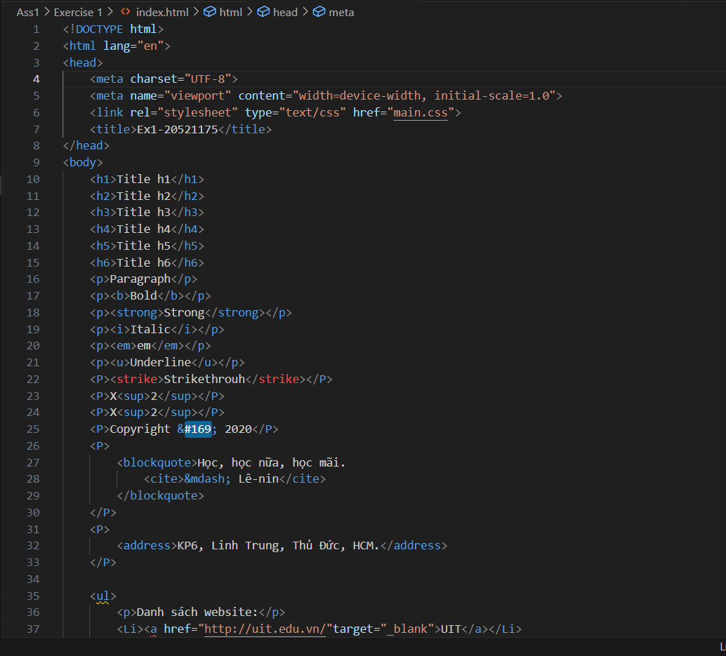

## First implementation – Table

## First implementation – Form

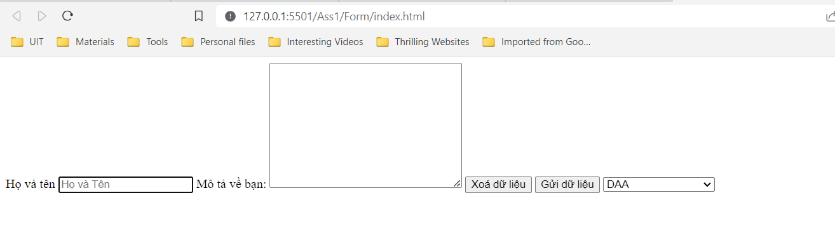

## Exercise 2.

Link github: <https://github.com/kudat-uit/Ex2-Lab2-WebCourse.git>

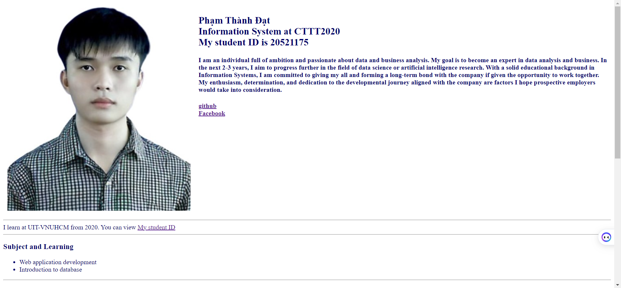

## Exercise 3. Using your knowledge of html and CSS, add the GENERAL NOTICE section of daa.uit.edu.vn to index-2.html

### index-2.html code

### app.css code

### Result

# HOMEWORK

## Homework 1. Upgrade your exercise 2 – The CV. Using CSS and making as this sample.

### index.html code

### main.css code

### Result

## Homework 2. Access this link and do as guidance.

### index.html code

### main.css code

### Result

## Homework 3. Access this link and do as guidance.

### index.html code

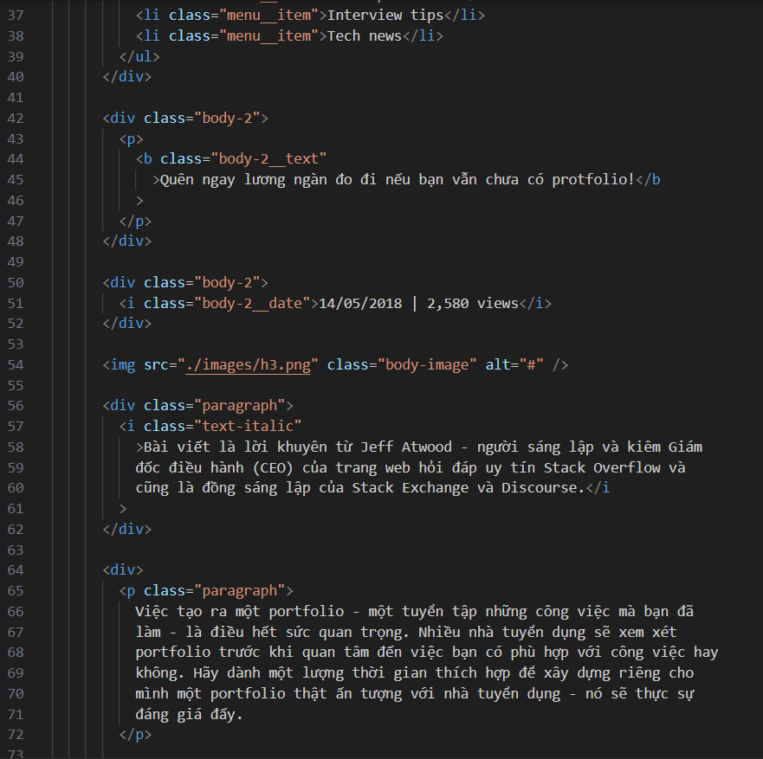

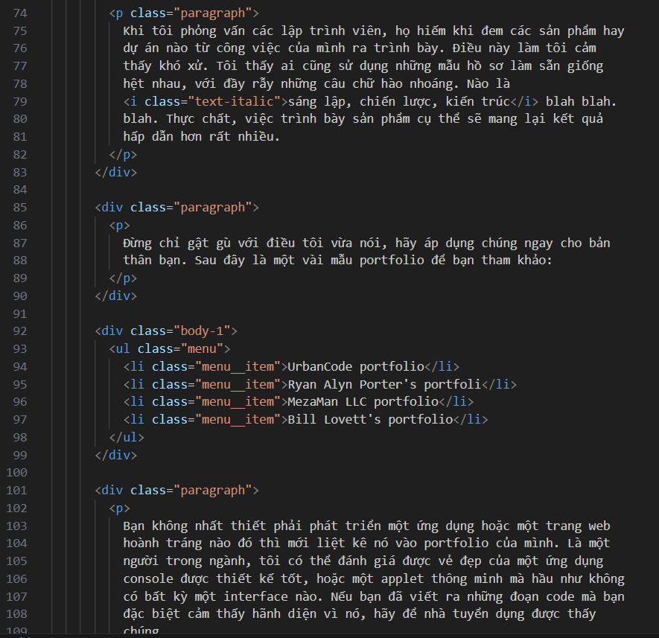

### main.css code

### Result

## Homework 4. Build A YouTube

### index.html code

### main.css code

### result

